ITP425 Web application penetration test Report
Mark To
May 8, 2026

May 8, 2026

Mr. Andy Portillo
Mgr InfoSec Architect and Engineering/ITP425.org Admin
Dear Mr. Portillo,
This report contains our findings and recommendations relating to the web application vulnerability security testing performed for ITP425.org.
Penetration testing is not intended to be an exhaustive test of all security controls nor does it provide any specific level of protection against possible breaches or compromise of systems, applications, and/or sensitive data. As a result, the projection of any conclusions, based on our testing, to future periods is subject to the risk that (1) changes are made to the systems or controls; (2) changes are required because of the regulations/compliance; or (3) new security vulnerabilities and exploits are discovered that may alter the validity of such conclusions. The findings included within this report were identified as of the following specific periods in time:
Assessment Service | Start Date | End Date
Web Application Vulnerability Assessment and Penetration Testing | 03/25/2025 | 05/08/2025

This report is intended solely for use by the management of ITP425.org. We appreciate the courtesies and cooperation extended to us during this project and the opportunity to be of service to ITP425.org. Please contact Mr. Mark To, Vulnerability Assessment Analysis at markchunto04@gmail.com, if you have any questions regarding this report.

I. Executive Summary 1
Background 1
Objective of the Vulnerability Assessment 1
Scope 1
Results 1
II. Web Application Findings 3
1. Security Misconfiguration 3
2. Vulnerable and Outdated Components 5
3. Identification and Authentication Failures 6
4. Broken Access Control 10
5. Injection 13
6. Server-Side Request Forgery 17
7. Insecure Deserialization 21
III. Appendix A 24
Methodology 24
Root Cause Description Table 25
OWASP Top 10 Description Table 25
CWE Top 25 Table 27

Executive Summary

Background
Security of technology and information assets is an important priority within University of Southern California. As threats to data and systems continuously evolve, so have the requirements for safeguarding our student and organizational information. The processes and people that support the security of technology are the key components in protecting these valuable business assets. Likewise, it is important to measure the security of technology assets to understand the ability to defend against cyber threats.

Objective of the Vulnerability Assessment
The primary objectives of the vulnerability assessment were to discover easily identifiable vulnerabilities on the ITP425.org’s external presence by conducting web application vulnerability scans. As part of the testing, the Vulnerability Assessment and Penetration Testing team (VAPT) attempted to achieve, but not limited to, the below objectives:
- Identify critical and high vulnerabilities on your external network through automated and manual vulnerability scanning techniques.
- Perform false-positive identification of vulnerabilities identified (when applicable).
The VAPT analyst used a multifaceted approach, including the use of automated and manual false-positive identification techniques to identify vulnerabilities.

Scope
We were provided the following in-scope network IP address ranges for testing:
Domain
itp425.org

Results
The VAPT team discovered the initial findings with Nexpose non-credential and credential vulnerability scan. The VAPT evaluated and inspected each of the discovered vulnerabilities from the Burp Suite output to perform root cause analysis and research into possible recommendations to fix current issues and help prevent future occurrences. The charts below contain the status of the overall level of risk currently living within ITP425.org computing environment. Risk scores are based on CVSS v.3.1 rankings: https://www.first.org/cvss/calculator/3.1
Sections II contain the findings that require attention to lower the risk of security compromises from occurring based on our review.
Summary of Web Application Findings by Risk Severity

Summary of Web Application Findings by Root Cause Analysis

Web Application Findings

Security Misconfiguration
Risk: High (H)
CVSS: 7.5
CVE: CVE-2021-41773 CWE: 552
Root Cause: Configuration Management
Category: OWASP Top 10 – A5

Finding:
Upon reconnaissance using a nikto scan, it was found that http://itp425.org:8082 was using Apache/2.4.49, which is vulnerable to path traversal attacks. Port 8082 also had misconfigurations. Notably, HTTP Trace method is enabled, /cgi-bin/test-cgi endpoint revealed system information, and the X-frame-options and X-content-type-options headers were not set (Figure 1, 2). Exploiting the Apache/2.4.49 path traversal vulnerability required sending a web request to access the /etc/passwd file (Figure 3, 4). Remote code execution did not work because the mod_cgi module was not enabled.

Risk:
Apache/2.4.49 is vulnerable to path traversal attacks because files are accessible to external parties. If the mod-cgi module is enabled on the Apache server, then it is at risk of remote code execution.

Affected system(s):
Hostname/Application Name | Service/Port
http://itp425.org:8082 | HTTP/8082

Screenshots:
Figure 1
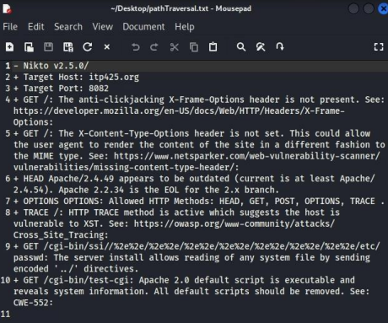
Figure 2
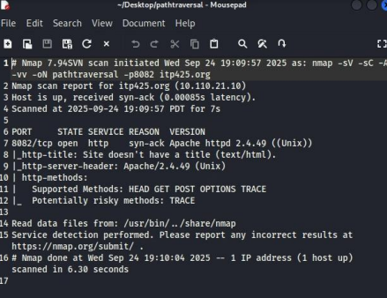
Figure 3
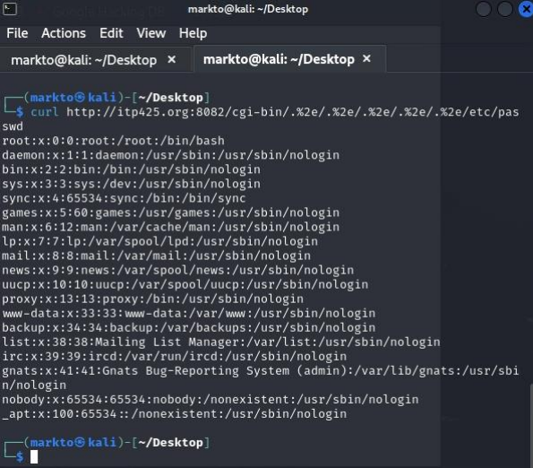
Figure 4
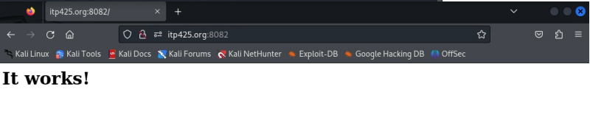

Recommendation:
We recommend updating Apache immediately. Updating Apache to HTTP Server 2.4.51 or later directly addresses CVE-2021-41773. Disable the mod-cgi module to prevent potential remove code execution. Apply the principle of least privilege to address path traversal attacks. Implement security headers in the underlying web server to improve the security of the web application.

Vulnerable and Outdated Components
Risk: High (H)
CVSS: 7.5
CVE: CVE-2014-0160 CWE: 125
Root Cause: Outdated Technology
Category: OWASP Top 10 – A6

Finding:
An enumeration scan on port 8443 revealed that http://itp425.org:8443 was running an outdated vulnerable version of OpenSSL which is susceptible to the Heartbleed vulnerability (CVE-2014-0160) (Figure 1, 2). The Heartbleed vulnerability is a persistent issue in OpenSSL versions older than 1.0.1g.

Risk:
This vulnerability allows unauthenticated attackers to obtain sensitive information from the server by sending packets that trigger a buffer overload. Heartbleed compromises the keys needed to securely encrypt traffic, the names and passwords of users, and the web application content itself. Attackers can eavesdrop traffic and steal data.

Affected system(s):
Hostname/Application Name | Service/Port
http://itp425.org:8443 | HTTP/8443

Screenshots:
Figure 1
Figure 2
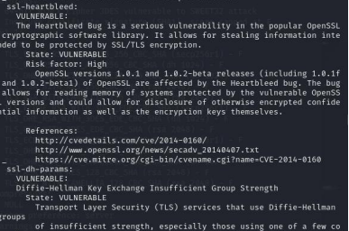

Recommendation:
We recommend to immediately update OpenSSL to versions 1.0.1g or later, preferably the most recent version. This directly addresses CVE-2014-0160.

Identification and Authentication Failures
Risk: Medium (M)
CVSS: N/A
CVE: N/A CWE: 200
Root Cause: Configuration Management
Category: OWASP Top 10 – A7

Finding:
The mutillidae login page provided useful enumeration, as it showed whether an account existed or had a username or password incorrect (Figure 1, 2). Using Burp Suite Intruder with the sniper attack against the mutillidae login username parameter, a wordlist of common usernames was tested against it (Figure 3, 4). It resulted in 19 valid usernames (Figure 5). Using the valid usernames, a cluster bomb attack was used, combining the 19 usernames and a list of passwords, resulting in 14 valid login credentials (Figure 6, 7).

Risk:
Vulnerabilities in authentication mechanisms can greatly aid user enumeration and reduce attack complexity. A lack of security such as unlimited authentication attempts could inevitably lead to an unauthorized login and attack escalation.

Affected system(s):
Hostname/Application Name | Service/Port
http://itp425.org:8880/index.php?page=login.php | HTTP/8880

Screenshots:
Figure 1
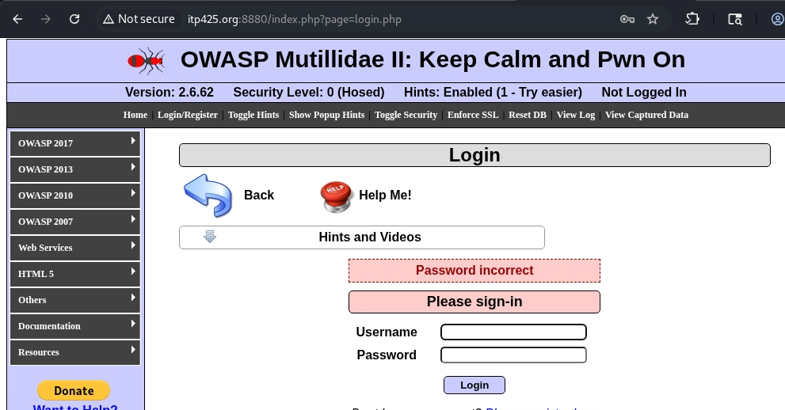

Figure 2
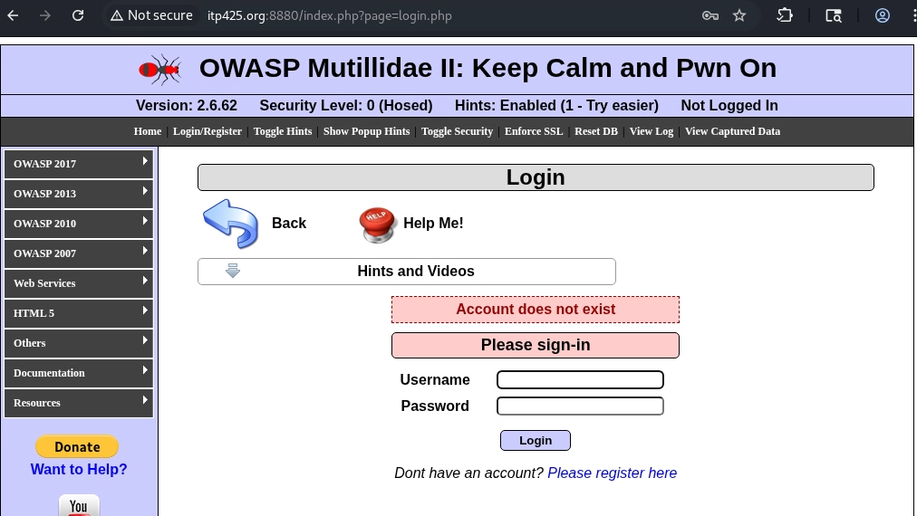
Figure 3
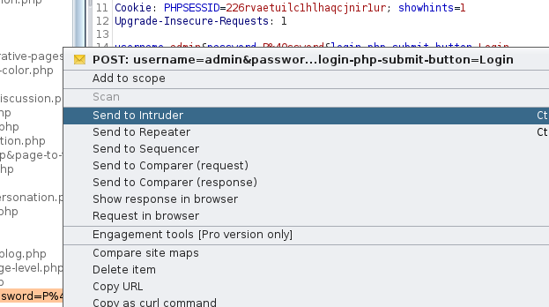
Figure 4
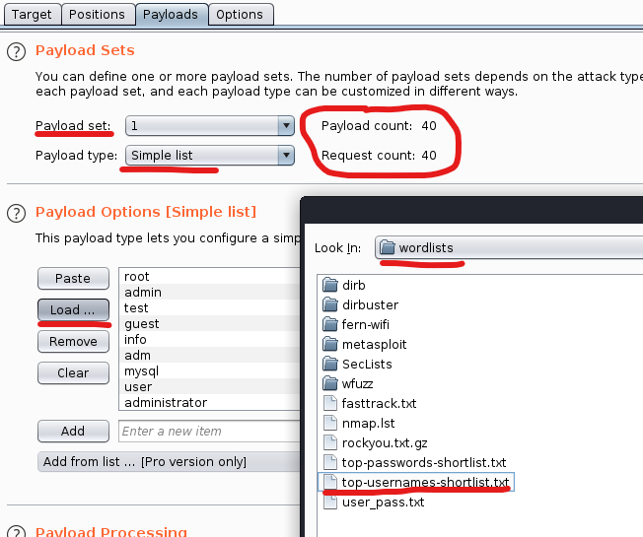

Figure 5
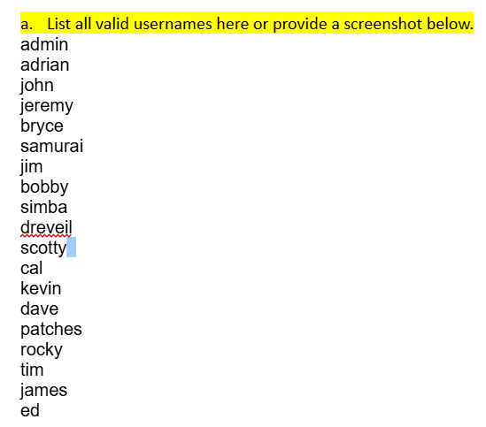
Figure 6
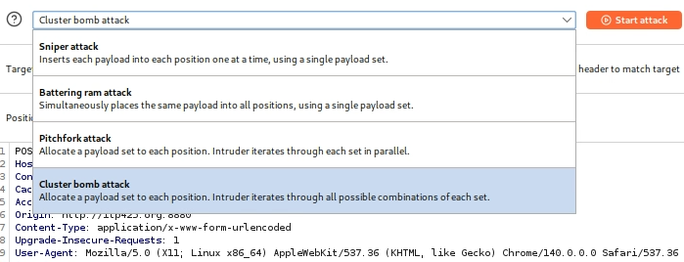

Figure 7
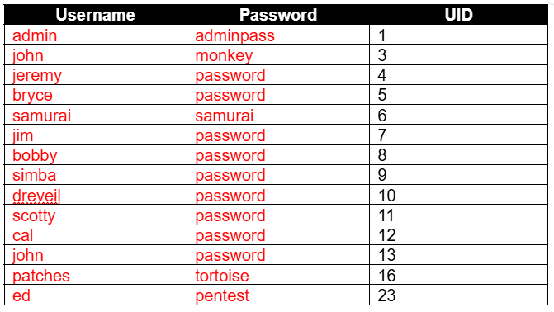

Recommendation:
We recommend implementing an error message that returns the same for every invalid login, such as “Invalid Credentials”. Restrict authentication attempts and enable temporary account lockout after said attempts have exceeded. To further harden security, implement multi factor authentication such as the addition of a two-factor or biometric authentication.

Broken Access Control
Risk: High (H)
CVSS: N/A
CVE: N/A CWE: 22
Root Cause: Access Control
Category: OWASP Top 10 – A1

Finding:
http://itp425.org:8882 (DVWA) file inclusion subdomain and the http://itp425.org:8880 domain was vulnerable to Local File Inclusion (LFI). Testing the URL parameters of DVWA revealed the success of retrieving system files in low security (Figure 1). Medium security setting was bypassed by doubling the path traversal (….//) (Figure 2). High security setting restricting the file:// parameter was bypassed by adding an additional forward slash (Figure 3). Further exploitation of the LFI vulnerability led to log poisoning. Reading the apache2/access.log in the Mutillidae subdomain was done by crafting a malicious PHP injection payload within an HTTP request (Figure 4, 5).

Risk:
Local File Inclusion is very risky due to the number of ways attackers can escalate their attack. LFI allows attackers to read sensitive files such as /etc/passwd and apache2/access.log, perform remote code execution, inject malicious scripts, and hijack session IDs.

Affected system(s):
Hostname/Application Name | Service/Port
http://itp425.org:8882/vulnerabilities/fi/ | HTTP/8882
http://itp425.org:8880 | HTTP/8880

Screenshots:
Figure 1
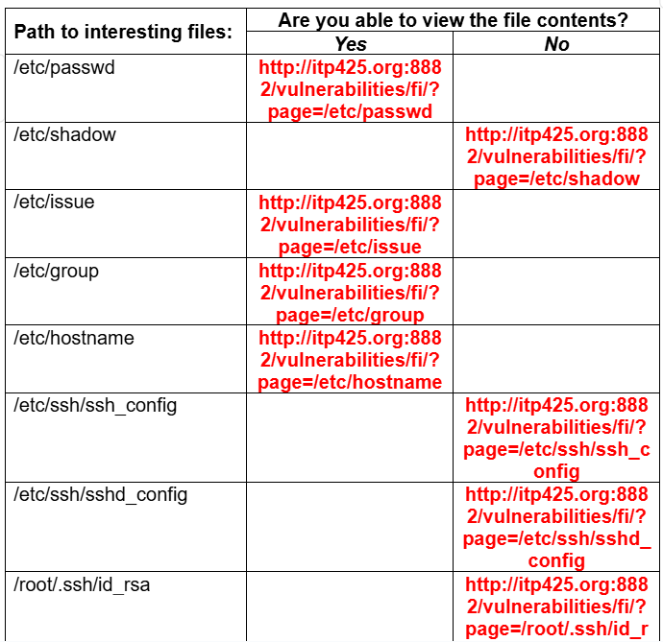
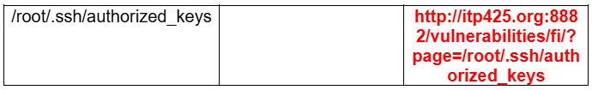
Figure 2
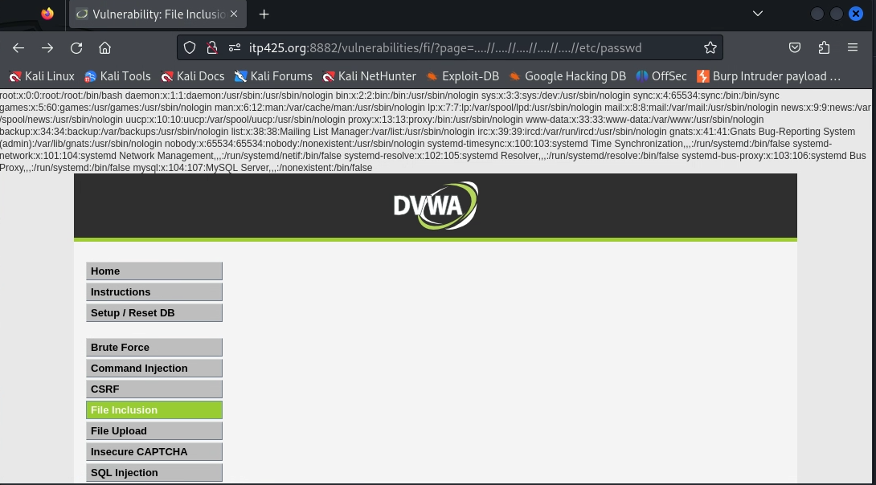
Figure 3
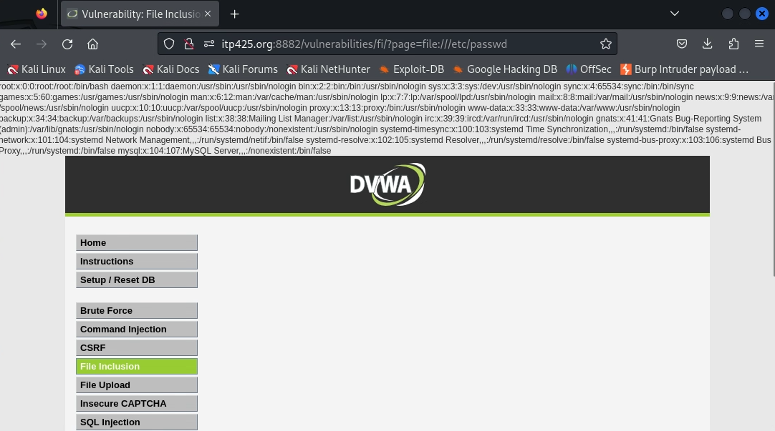

Figure 4
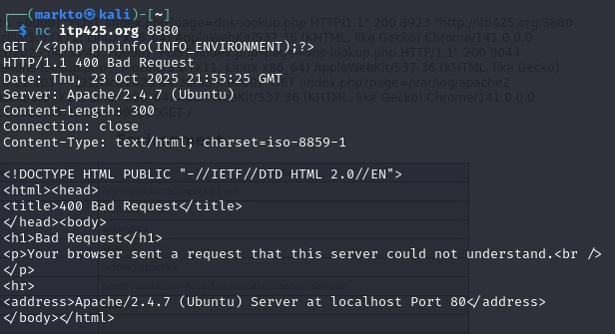
Figure 5
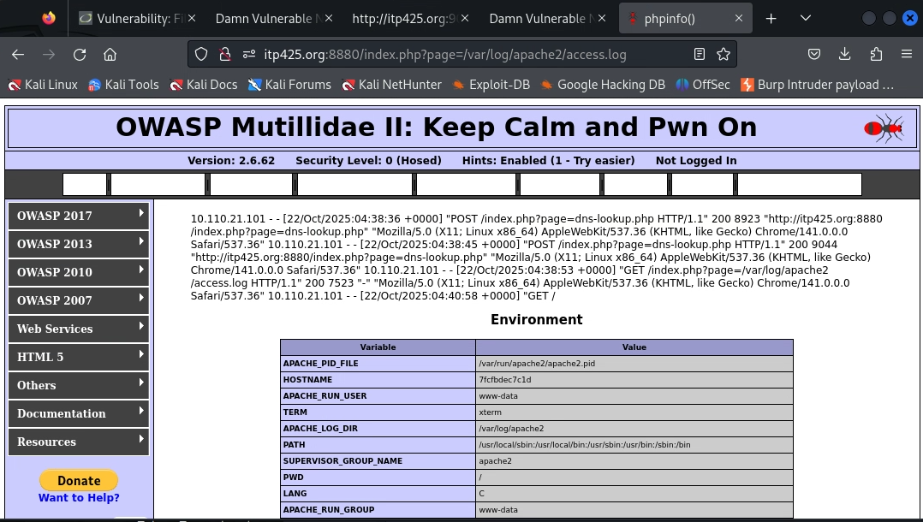

Recommendation:
We recommend disabling file inclusion and restrict file access to specific directories as soon as possible to minimize Mutillidae’s attack vector. Implementing input validation and sanitization to reject special characters will also mitigate file inclusion. Disabling PHP execution will help prevent code execution. An additional recommendation is implementing File Integrity Monitoring to ensure files are not tampered with.

Injection
Risk: Critical (C)
CVSS: N/A
CVE: N/A CWE: 78
Root Cause: Insecure Deployment
Category: OWASP Top 10 – A3

Finding:
Four web applications (DVWA, Mutillidae, bWAPP, and DVNA) were found vulnerable to OS command injection, allowing attacks to execute system commands and establish reverse shells. An initial ping test on DVWA’s command injection page revealed that there was insufficient input sanitization (Figure 1). Using readily crafted payloads, all four web application successfully connected to the attacking machine, gaining reverse shell access (Figure 2, 3, 4, 5, 6, 7, 8, 9).

Risk:
OS command injection is critical vulnerability because of the ability for attackers to bypass all security controls and gain unrestricted access control. The attacker can then escalate their attack to execute commands, access sensitive information, and install malware. Full system compromise also allows the attacker to pivot to attack other systems in the network.

Affected system(s):
Hostname/Application Name | Service/Port
http://itp425.org:8088/commandi.php | HTTP/8088
http://itp425.org:9090 | HTTP/9090
http://itp425.org:8882/vulnerabilities/exec/ | HTTP/8882
http://itp425.org:8880/index.php?page=dns-lookup.php | HTTP/8880

Screenshots:
Figure 1
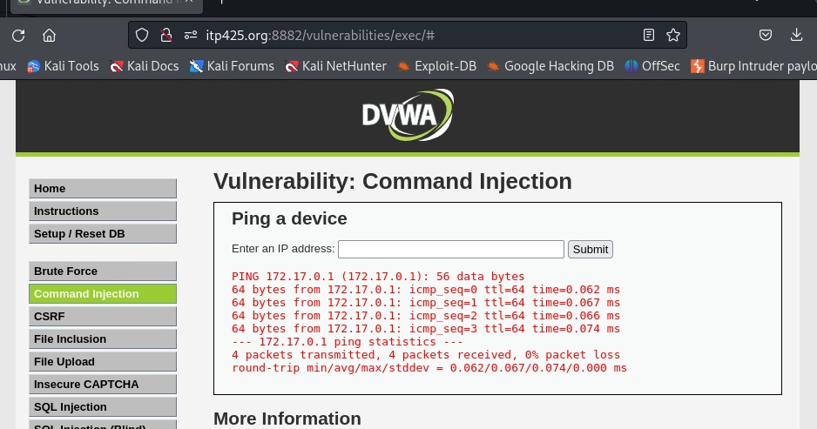
Figure 2
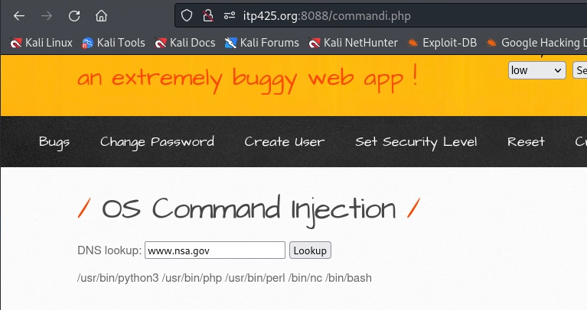
Figure 3
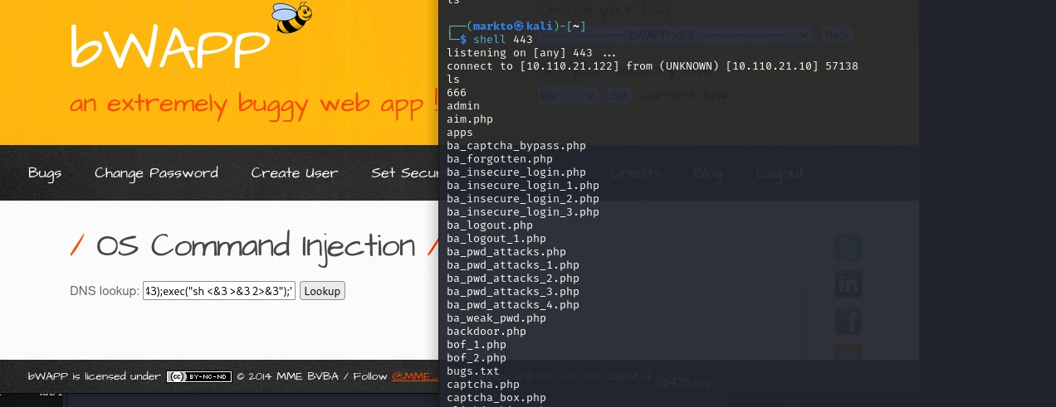
Figure 4
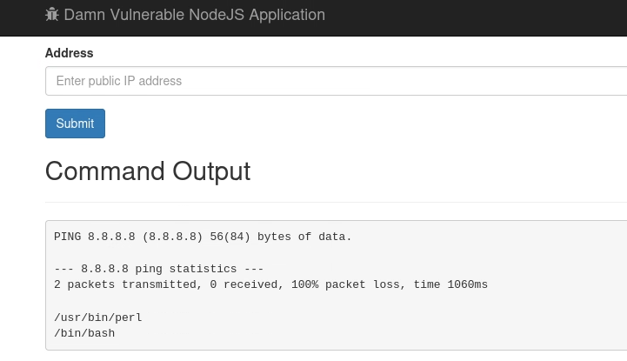
Figure 5
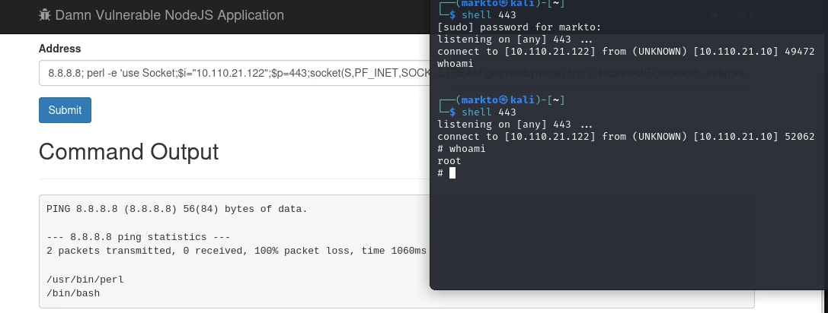
Figure 6
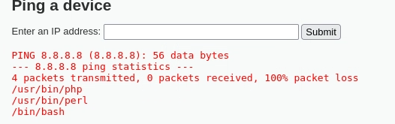
Figure 7
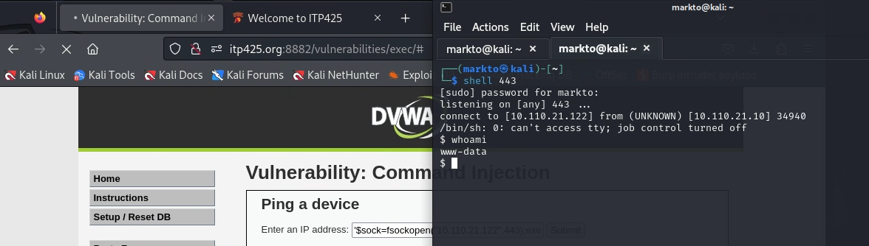
Figure 8
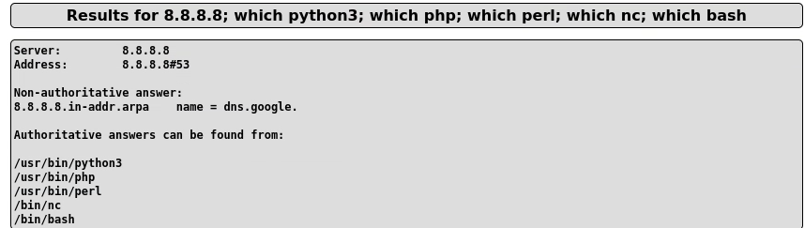

Figure 9
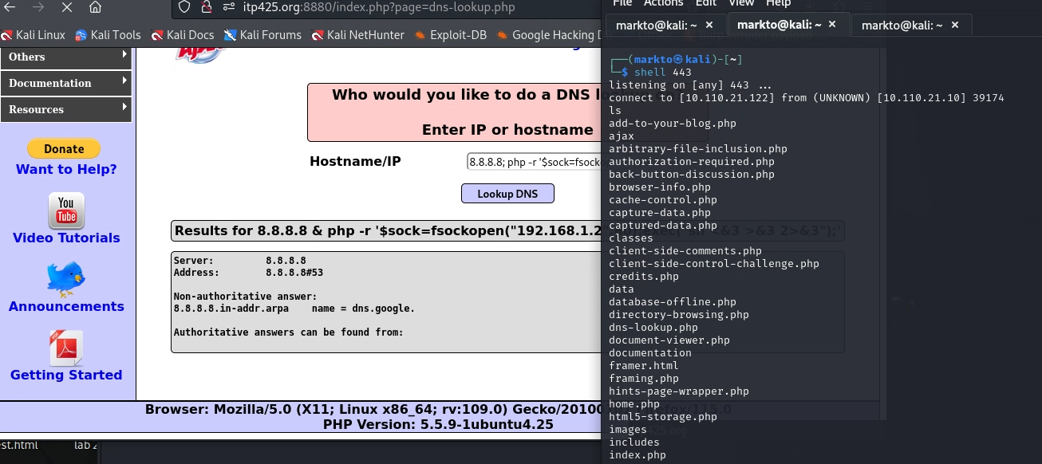

Recommendation:
We recommend to immediately remove any access to OS command injection and execution such as system(). After removing any potential vectors for OS command injection, implement user input validation to allow a list of safe values and blacklist everything else to ensure no malicious values are missed. Implement least privilege principle to restrict user capabilities.

Server-Side Request Forgery
Risk: High (H)
CVSS: 7.2
CVE: CVE-2021-21311 CWE: 918
Root Cause: Insecure Deployment
Category: OWASP Top 10 – A10

Finding:
http://itp425.org:9000 was found vulnerable to Server-Side Request Forgery, allowing potential attackers to force the server to make HTTP requests to internal network resources. The payload file:///etc/flag/txt retrived filesystem containing the internal gateway IP (Figure 1, 2). A port scan was then performed on ports 80, 9090, 9000, and 8883 by crafting URLs with the internal gateway IP and ports, revealing HTML content (Figure 3, 4, 5, 6, 7, 8, 9, 10, 11, 12). This SSRF vulnerability was an initial access vector to discover internal services. Port 8883 was identified as vulnerable to XML External Entity injection, leading to further exploitation.

Risk:
SSRF vulnerabilities allow attackers to bypass network security protocols such as firewalls, VPNs, and ACLs. It leverages the trust between the server and internal systems. SSRF can expose interfaces and databases that should not be accessible to unauthorized individuals, and can lead to remote code execution.

Affected system(s):
Hostname/Application Name | Service/Port
http://itp425.org:80 | HTTP/80
http://itp425.org:9090 | HTTP/9090
http://itp425.org:9000 | HTTP/9000
http://itp425.org:8883 | HTTP/8883

Screenshots:
Figure 1
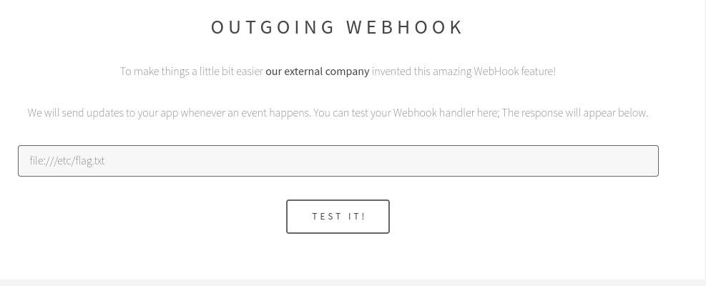

Figure 2
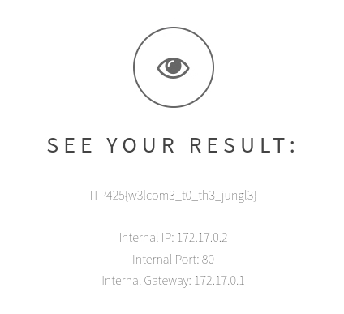
Figure 3
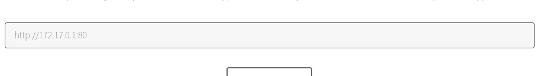
Figure 4
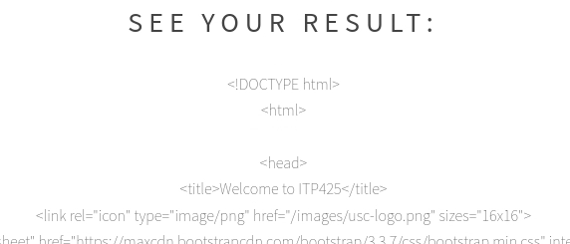
Figure 5
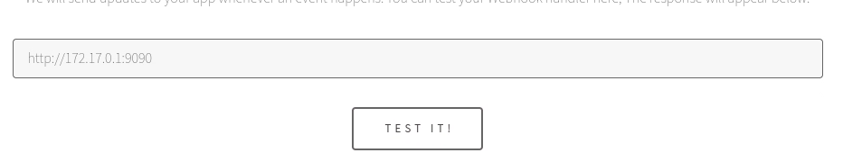
Figure 6

Figure 7
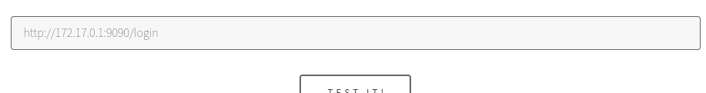
Figure 8
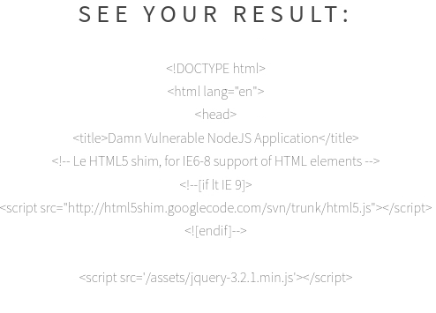
Figure 9
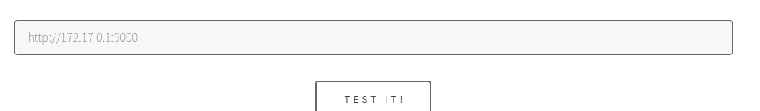
Figure 10
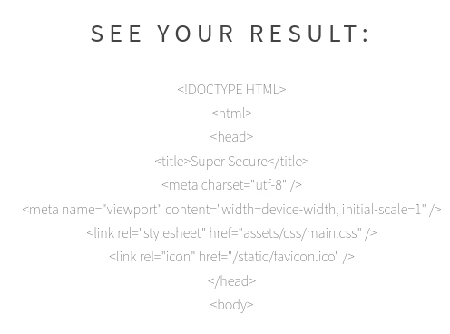
Figure 11
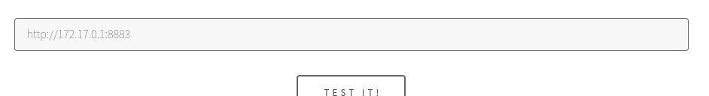
Figure 12
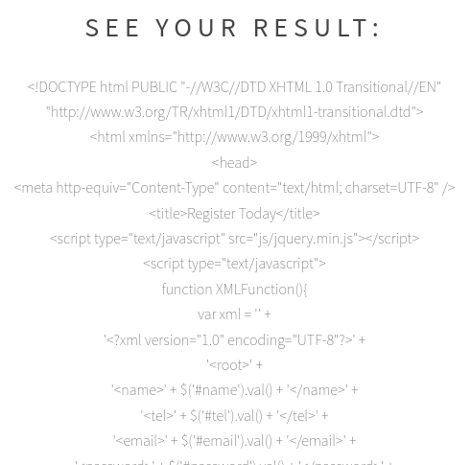

Recommendation:
We recommend implementing URL validation; accept http:// or https:// while denying file:// or other protocols. Create access control lists to block IP ranges. Create VLANS, subnets, and firewall rules to prevent access to internal interfaces.

Insecure Deserialization
Risk: High (H)
CVSS: 8.8
CVE: CVE-2024-22320 CWE: 502
Root Cause: Configuration Management
Category: OWASP Top 10 – A8

Finding:
The JavaServerFaces (JSF) application in http://itp425.org:8008 was found vulnerable to insecure deserialization through the javax.faces.ViewState parameter, leading to remote code execution with root privileges. Port scanning revealed the server Apache Tomcat 8.5.55 hosting a JSF application (Figure 1). Analysis of the javax.faces.ViewState parameter and its value in Burp Suite's Decoder showed the data was Base64-encoded but did not contain recognizable Java serialization magic bytes (rO0), indicating encryption (Figure 2). Common injection vulnerabilities in Mutillidae enabled filesystem enumeration, revealing tomcat-stuff.zip’s location. The extracted web.xml.bak file revealed critical cryptographic parameters, including encryption type, SECRET key, and MAC algorithm (Figure 3). A python script was created to decode the ViewState parameters (Figure 4). A exploit payload was then created containing a reverse shell command. Upon deserialization, the server executed the payload, establishing a reverse shell connection and provided root level access in the /home/ubuntu directory (Figure 5, 6, 7).

Risk:
This vulnerability is a critical risk that can enable complete system compromise without authentication. It is remotely exploitable, and bypasses cryptographic techniques by leveraging configuration weaknesses. Attackers can gain unrestricted system control and exfiltrate data.

Affected system(s):
Hostname/Application Name | Service/Port
http://itp425.org:8008/userSubscribe/faces | HTTP/8008

Screenshots:
Figure 1
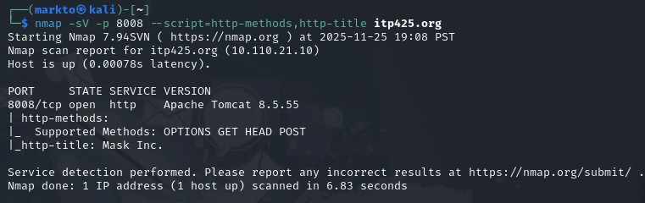

Figure 2
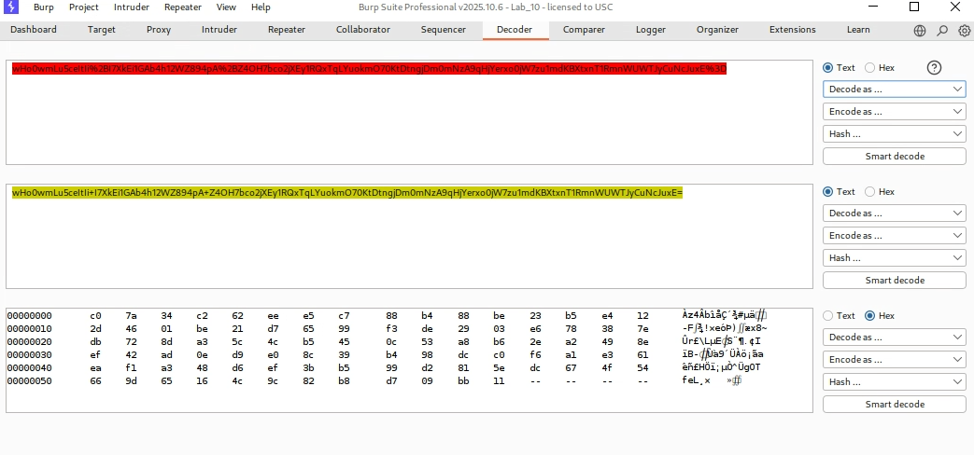
Figure 3
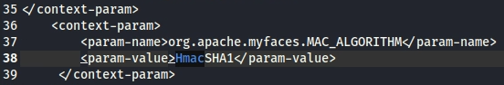
Figure 4
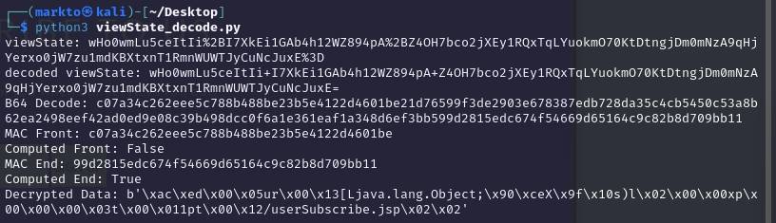
Figure 5
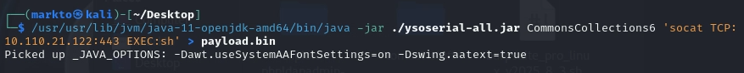

Figure 6
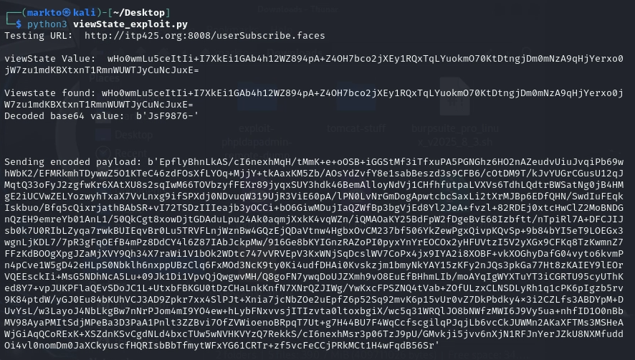
Figure 7
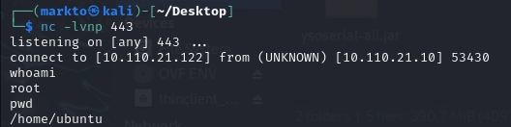

Recommendation:
We recommend adopting AES encryption instead of DES as is provides a much wider range of bit key sizes for better security. Use separate keys for encryption and MAC. Use the principle of least privilege for filesystem permissions to restrict unwanted access. Update to the latest security settings as older versions more potential to be vulnerable. Enable IDS/IPS/SIEM monitoring for potential deserialization attack patterns or failed attempts.

Appendix A

Methodology
The Vulnerability Assessment team uses a combination of several penetration testing frameworks depending on the scope of work, such as Penetration Testing Execution Standard (PTES) for networking penetration testing, Open Source Web Application Security Project (OWASP) for web app security testing and Open Source Security Testing Methodology Manual (OSSTMM) to support compliance/regulations, security operations and guidance. In addition to the above frameworks, the VA team will be performing the following:
- Information Gathering – The information-gathering phase of our penetration testing methodology consists of service enumeration, network mapping, banner reconnaissance and more. Host and service discovery efforts results in a compiled list of all accessible systems and their respective services with the goal of obtaining as much information about the systems as possible.
- Threat Modeling – With the information collected from the previous step, security testing transitions to identifying vulnerabilities within systems. This begins with automated scans initially but quickly develops into deep-dive manual testing techniques. The VA team will consult with the Cyber Threat Intelligence (CTI) team to gather intel into latest hacking campaign and what vulnerabilities are being exploited in the public against the list of assets that were identified and categorized into threat categories.
- Vulnerability Analysis – The vulnerability analysis phase involves the documenting and analysis of vulnerabilities discovered as a result of the previous network pen testing steps. This includes the analysis of out from the various security tools and manual testing techniques. At this point, the VA team will consult with the Host Security team to determine accurate system information and create a list of attractive vulnerabilities, suspicious services and items worth researching further has been created and weighted for further analysis. In essence, the plan of attack is developed here.
- Exploitation – Unlike a vulnerability assessment, a penetration test takes it a bit further specifically by way of exploitation. Exploitation involves actually carrying out the vulnerability’s exploit (ie: buffer overflow) in an effort to be certain if the vulnerability is truly exploitable. During a test, this phase consists of employing heavy manual testing tactics and is often quite time-intensive. Exploitation may include, but is not limited to: buffer overflow, SQL injection, OS commanding and more.
- Reporting – The reporting step is intended to deliver, rank and prioritize findings and generate a clear and actionable report, complete with evidence, to the project stakeholders. The presentation of findings can occur via Webex or in-person – whichever format is most conducive for communicating results.

Root Cause Description Table
Root Cause Area | Root Cause Description
Configuration Management | Software or network devices have been deployed without the appropriate security settings or are misconfigured increasing the risk of application or system compromise. This introduces avenues for exploration, easily unauthenticated login credentials, weak encryption and cleartext passwords to name a few.
Patch Management | Patches related to single software deployments can introduce vulnerabilities if the system software is not monitored for updates.
Unsupported Technology | Software that is unsupported is subject to vulnerabilities as the developer of the software is not providing patches as security issues are uncovered.
Access Control | Access restrictions are not sufficient, allowing users with no legitimate need additional or escalated privileges.
Malicious Code | These are findings that result from virus, malware or other malicious code that has entered the system.
Legal or Regulatory | These are items resulting in legal (copyright), compliance violations or may not conform to regulatory standards.
Insecure Software Development | These are findings resulting from poor secure software development practices (not properly validating user input, lack of crypto, etc.).

OWASP Top 10 Description Table
OWASP Top 10 Application Security Risk Area | Application Security Risk Description
A1: Broken Access Control | Restrictions on what authenticated users are allowed to do are not properly enforced. Attackers can exploit these flaws to access unauthorized functionality and/or data, such as access other users’ accounts, view sensitive files, modify other users’ data, change access rights, etc.
A2: Cryptographic Failures | Many web applications and APIs do not properly protect sensitive data, such as financial, health care and personally identifiable information (PII). Attackers may steal or modify such weakly protected data to conduct credit card fraud, identity theft or other crimes. Sensitive data deserves extra protection, such as encryption at rest or in transit, as well as special precautions when exchanged with the browser.
A3: Injection | Injection flaws, such as SQL, NoSQL, OS and LDAP injection, occur when untrusted data is sent to an interpreter as part of a command or query. The attacker’s hostile data can trick the interpreter into executing unintended commands or accessing data without proper authorization.
A4: Insecure Design | Insecure design is a broad category representing different weaknesses, expressed as “missing or ineffective control design.” Insecure design is not the source for all other Top 10 risk categories. An insecure design cannot be fixed by a perfect implementation as by definition, needed security controls were never created to defend against specific attacks.
A5: Security Misconfiguration | Good security requires having a secure configuration defined and deployed for the application, frameworks, application server, web server, database server, platform, etc. Secure settings should be defined, implemented and maintained, as defaults are often insecure. Additionally, software should be kept up to date.
A6: Vulnerable and Outdated Components | Components, such as libraries, frameworks and other software modules, run with the same privileges as the application. If a vulnerable component is exploited, such an attack can facilitate serious data loss or server takeover. Applications and APIs using components with known vulnerabilities may undermine application defenses and enable various attacks and impacts.
A7: Identification and Authentication Failures | Application functions related to authentication and session management are often implemented incorrectly, allowing attackers to compromise passwords, keys or session tokens, or to exploit other implementation flaws to assume other users’ identities temporarily or permanently.
A8: Software and Data Integrity Failures | Focuses on making assumptions related to software updates, critical data, and CI/CD pipelines without verifying integrity. Insecure deserialization often leads to remote code execution. Even if deserialization flaws do not result in remote code execution, they can be used to perform attacks, including replay attacks, injection attacks and privilege escalation attacks.
A9: Security Logging and Monitoring Failures | Insufficient logging and monitoring, coupled with missing or ineffective integration with incident response, allows attackers to further attack systems, maintain persistence, pivot to more systems,  and tamper, extract, or destroy data. Most breach studies show time to detect a breach is over 200 days, typically detected by external parties rather than internal processes or monitoring.
A10: Server-Side Request Forgery (SSRF) | SSRF flaws occur whenever a web application is fetching a remote resource without validating the user-supplied URL. It allows an attacker to coerce the application to send a crafted request to an unexpected destination, even when protected by a firewall, VPN, or another type of network access control list (ACL).

CWE Top 25 Table
Rank | ID | Name
1 | CWE-787 | Out-of-bounds Write
2 | CWE-79 | Improper Neutralization of Input During Web Page Generation ('Cross-site Scripting')
3 | CWE-89 | Improper Neutralization of Special Elements used in an SQL Command ('SQL Injection')
4 | CWE-20 | Improper Input Validation
5 | CWE-125 | Out-of-bounds Read
6 | CWE-78 | Improper Neutralization of Special Elements used in an OS Command ('OS Command Injection')
7 | CWE-416 | Use After Free
8 | CWE-22 | Improper Limitation of a Pathname to a Restricted Directory ('Path Traversal')
9 | CWE-352 | Cross-Site Request Forgery (CSRF)
10 | CWE-434 | Unrestricted Upload of File with Dangerous Type
11 | CWE-476 | NULL Pointer Dereference
12 | CWE-502 | Deserialization of Untrusted Data
13 | CWE-190 | Integer Overflow or Wraparound
14 | CWE-287 | Improper Authentication
15 | CWE-798 | Use of Hard-coded Credentials
16 | CWE-862 | Missing Authorization
17 | CWE-77 | Improper Neutralization of Special Elements used in a Command ('Command Injection')
18 | CWE-306 | Missing Authentication for Critical Function
19 | CWE-119 | Improper Restriction of Operations within the Bounds of a Memory Buffer
20 | CWE-276 | Incorrect Default Permissions
21 | CWE-918 | Server-Side Request Forgery (SSRF)
22 | CWE-362 | Concurrent Execution using Shared Resource with Improper Synchronization ('Race Condition')
23 | CWE-400 | Uncontrolled Resource Consumption
24 | CWE-611 | Improper Restriction of XML External Entity Reference
25 | CWE-94 | Improper Control of Generation of Code ('Code Injection')

